1. Configuration of Network Devices using Packet Tracer tools (Hub, Switch, Ethernet, Broadcast)

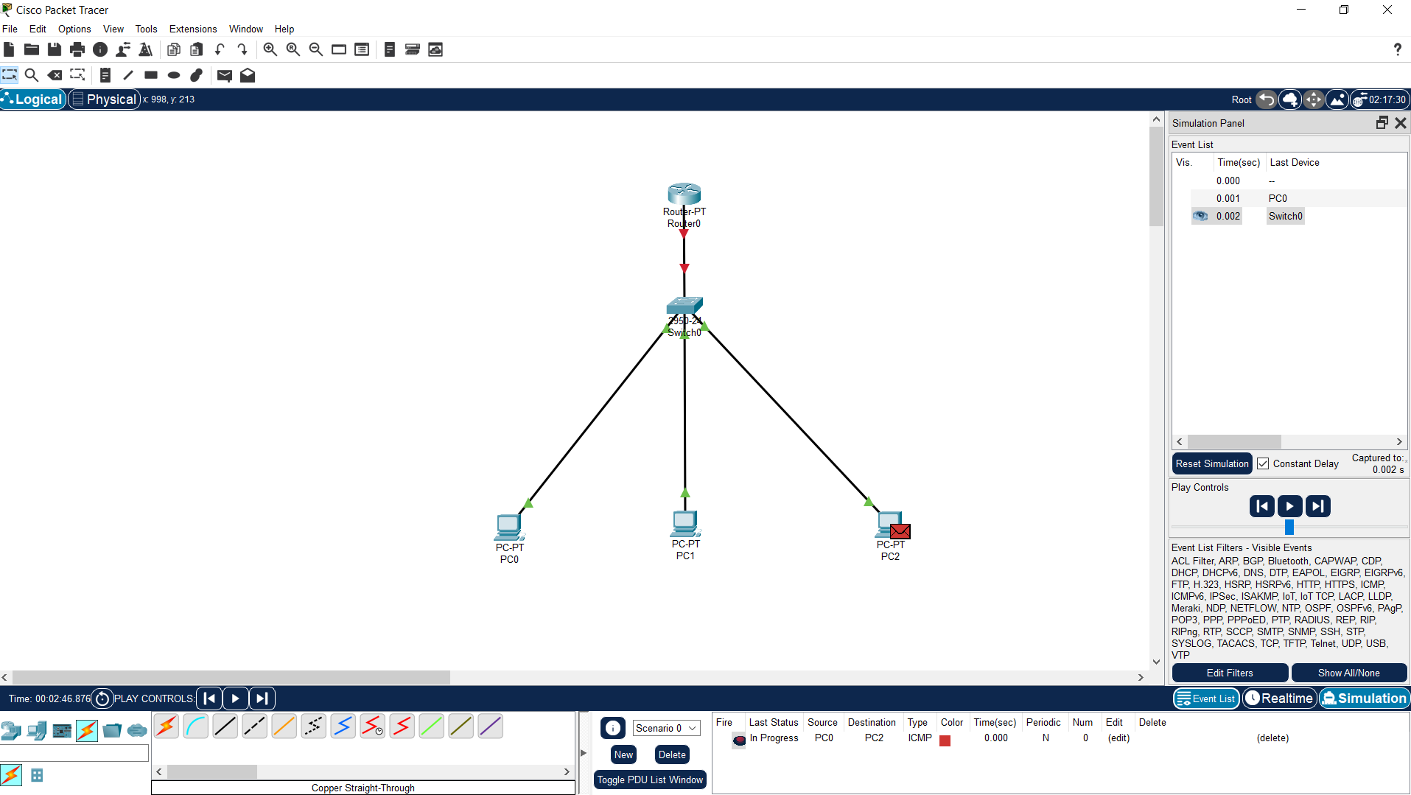

1. Design and Configuration of Star Topologies using Packet Tracer.

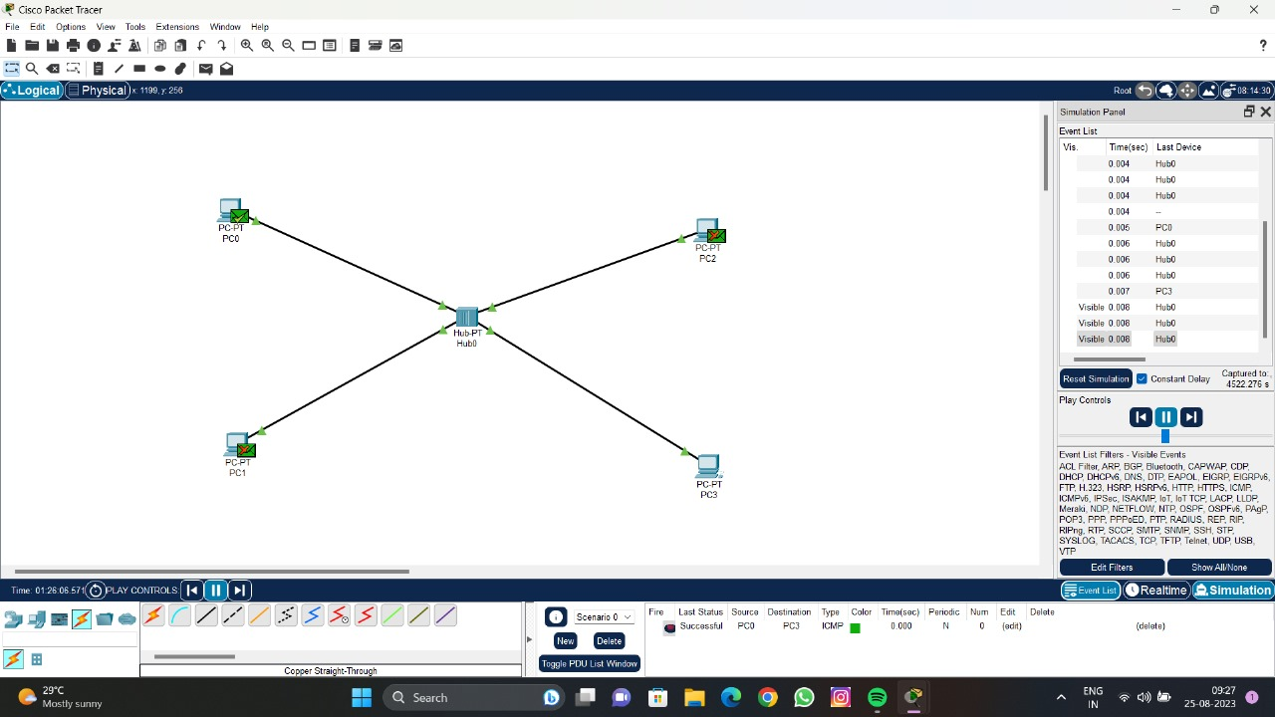

1. Design and Configuration of BUS Topologies using Packet Tracer

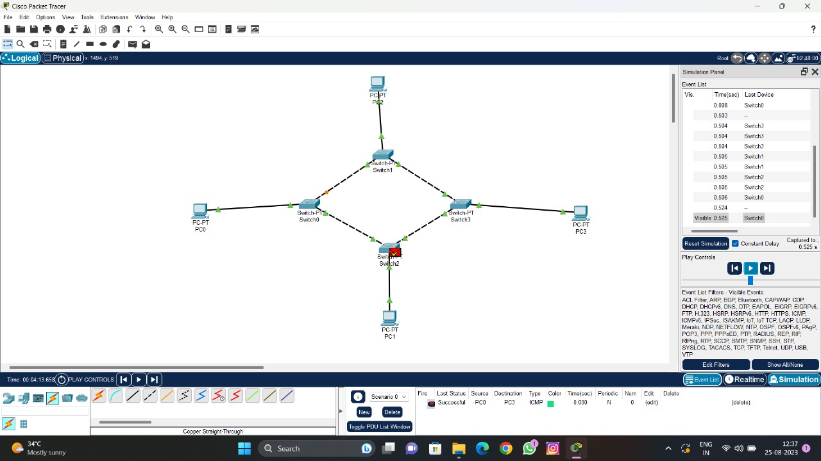

1. Design and Configuration of RING Topologies using Packet Tracer.



1. Design and Configuration of Mesh Topologies using Packet Tracer

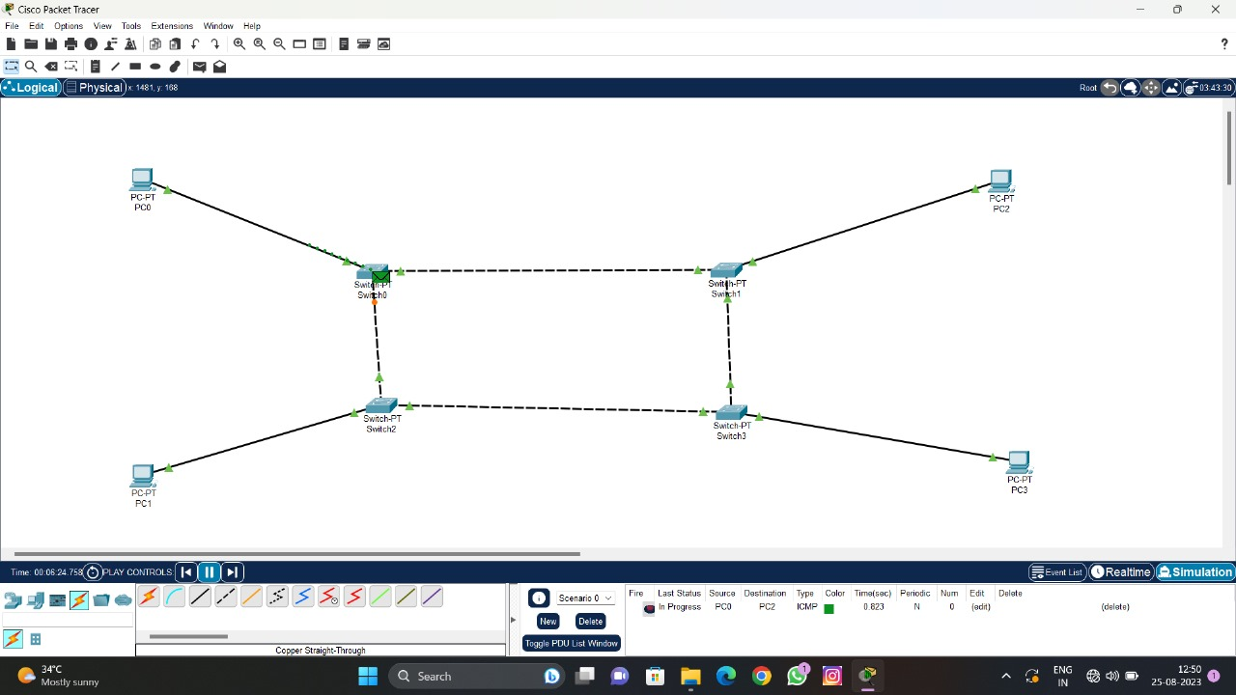

1. Design and Configuration of Tree Topologies using Packet Tracer

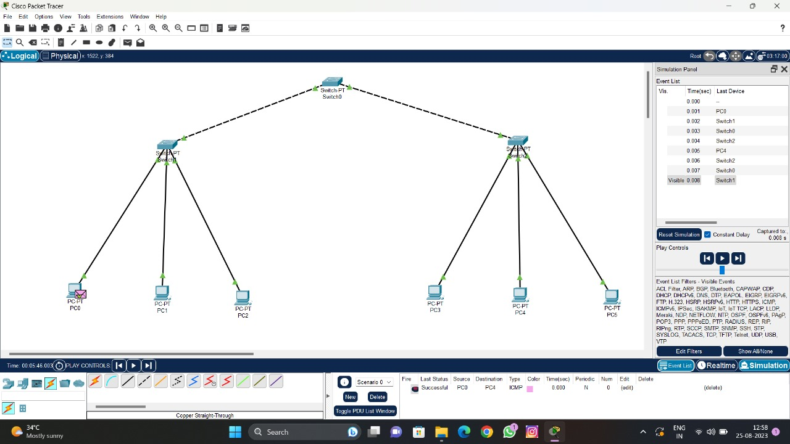

1. Design and Configuration of Hybrid Topologies using Packet Tracer.

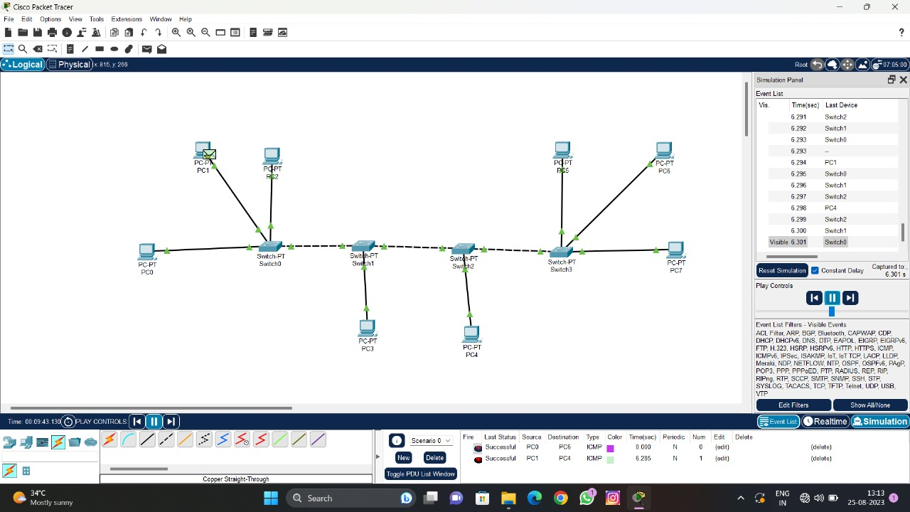

1. Data Link Layer Traffic Simulation using Packet Tracer Analysis of ARP.

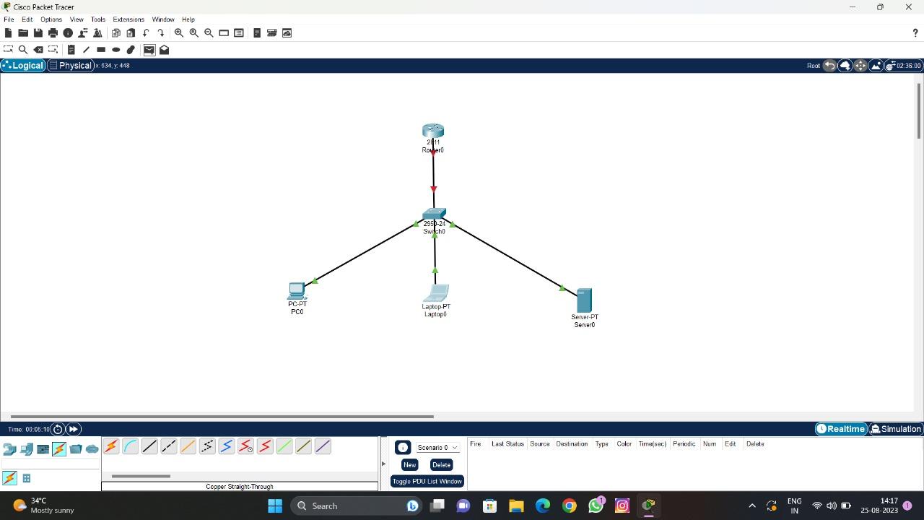

1. Data Link Layer Traffic Simulation using Packet Tracer Analysis of CSMA/CD & CSMA/CA.

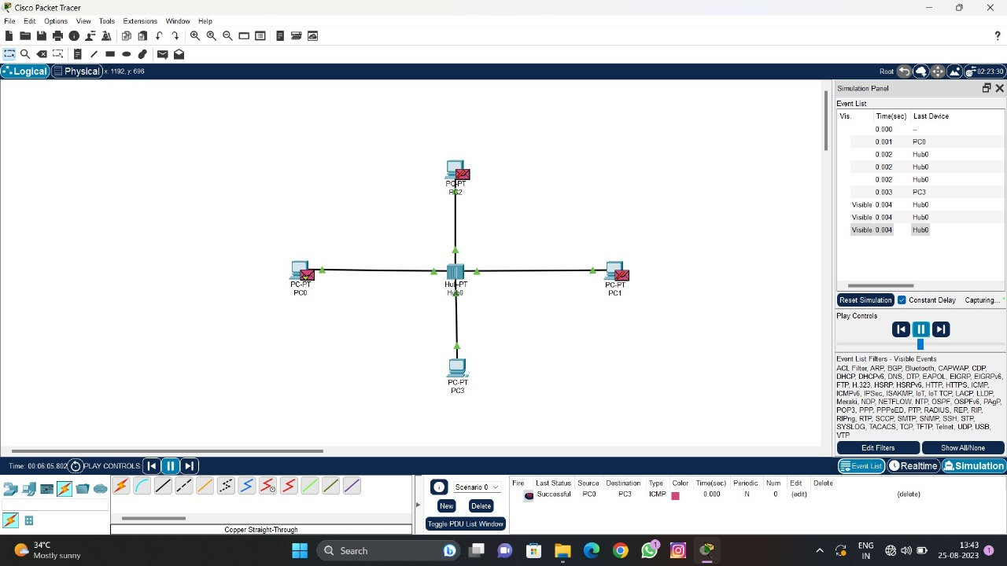

1. Data Link Layer Traffic Simulation using Packet Tracer Analysis of CSMA/CD & CSMA/CA.

